ODPi Infrastructure – Cost and Administration
Current machine list on SoftLayer
Device Name | Usage | Device Type | Location | Public IP | Private IP
nexus-odp.softlayer.com | Nexus Server | Virtual Server | San Jose 1 | 158.85.169.151 | 10.122.103.243
odp-bvt1.softlayer.com | CentOS 7 BVT | Virtual Server | San Jose 1 | 169.54.144.110 | 10.122.103.231
odp-bvt2.softlayer.com | CentOS 7 BVT | Virtual Server | San Jose 1 | 198.23.66.211 | 10.90.126.88
odp-bvt3.softlayer.com | CentOS 7 BVT | Virtual Server | San Jose 1 | 169.54.144.125 | 10.122.103.201
odp-bvt4.softlayer.com | CentOS 7 BVT | Virtual Server | San Jose 1 | 169.54.144.114 | 10.122.103.247
odp-bvt5.softlayer.com | CentOS 6 BVT | Virtual Server | San Jose 1 | 169.54.144.107 | 10.122.103.202
odp-bvt6.softlayer.com | CentOS 6 BVT | Virtual Server | San Jose 1 | 169.54.144.112 | 10.122.103.207
odp-ci1.softlayer.com | Jenkins Master | Virtual Server | San Jose 1 | 198.11.219.190 | 10.90.126.76
odp-ci2.softlayer.com | CentOS 7 Build | Virtual Server | San Jose 1 | 158.85.169.153 | 10.122.103.209
odp-ci3.softlayer.com | CentOS 6 Build | Virtual Server | San Jose 1 | 198.11.219.188 | 10.90.126.79
odp-ci4.softlayer.com | Debian 7 Build | Virtual Server | San Jose 1 | 158.85.169.158 | 10.122.103.216
odp-ci5.softlayer.com | Ubuntu 14 Build | Virtual Server | San Jose 1 | 198.11.219.189 | 10.90.126.83
repo-odp.softlayer.com | Repo Server | Virtual Server | San Jose 1 | 50.23.91.197 | 10.55.33.132
Base cost per machine: $265.56 (CPU 8x2.0 GHz Cores, 32 GB RAM, 100 GB SAN Disk)
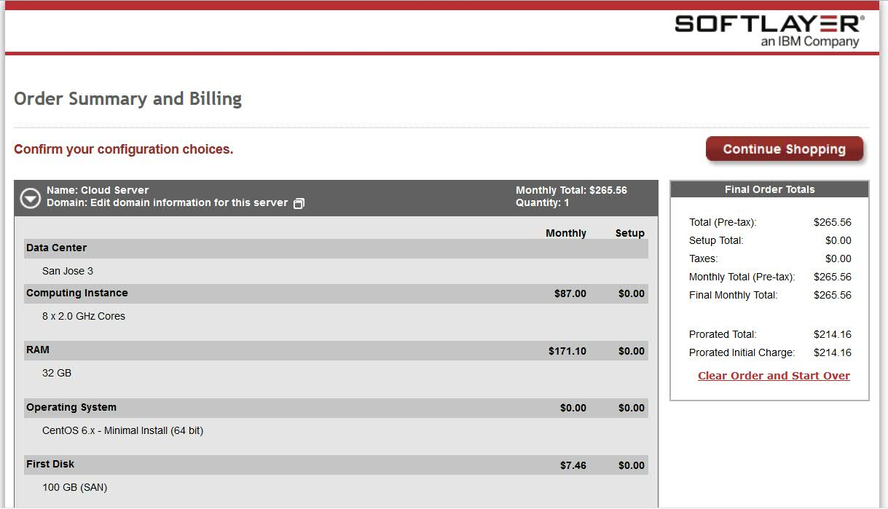
Cost per month (13 virtual servers): $3,452.28
Cost per year (13 virtual servers): $41,427.36
Administration Console
https://control.softlayer.com/
Contact Raj Desai (rddesai@us.ibm.com)
SoftLayer SSL VPN Portal
https://vpn.den01.softlayer.com/prx/000/http/localhost/login
For credentials contact Raj Desai (rddesai@us.ibm.com)
Linux Foundation Domain Name Management
http://build.odpi.org
http://nexus.odpi.org
http://repo.odpi.org
SoftLayer Operating System Support
CentOS 5.x
CentOS 6.x
CentOS 7.x
CloudLinux 5.x
CloudLinux 6..x
CoreOS Stable
Debian GNU 6.x
Debian GNU 7.x
Debian GNU 8.x
Windows Server 2008 (DE, EE, SE)
Windows Server 2012 (DE, SE)
Red Hat Enterprise Linux 5.x
Red Hat Enterprise Linux 6.x
Red Hat Enterprise Linux 7.x
Ubuntu Linux 12.04
Ubuntu Linux 14.04

ODPi Target Platforms
- xLinux (x86_64)
  - CentOS 6 (Existing)
  - Windows Server 2012 (IBM to provide and manage)
- Power 8 LE (ppc64le)
  - RHEL 7.1 (IBM to provide and manage)
Note: SoftLayer planning on providing support in 2016.
- zLinux LE (s390x)
  - RHEL 7.1 (IBM to provide and manage)
Note: SoftLayer planning on providing support in 2016.

ODPi Target Cost 2016
Device Name | Usage | Device Type | Monthly Cost
nexus-odp.softlayer.com | Nexus Server | Virtual Server | $265.56
repo-odp.softlayer.com | Repo Server | Virtual Server | $265.56
odp-ci1.softlayer.com | Jenkins Master | Virtual Server | $265.56
odp-ci2.softlayer.com | CentOS 7 Build | Virtual Server | $265.56
odp-ci3.softlayer.com | CentOS 6 Build | Virtual Server | $265.56
odp-ci4.softlayer.com | Debian 7 Build | Virtual Server | $265.56
odp-ci5.softlayer.com | Ubuntu 14 Build | Virtual Server | $265.56
odp-ci6.softlayer.com | Windows 2012 Build | Virtual Server | $356.19
odp-ci7.softlayer.com | RHEL 7.1 ppc64le Build | Bare Metal | $298.19
odp-ci8.sotlayer.com | RHEL 7.1 s390x Build | Bare Metal | $298.19
odp-bvt1.softlayer.com | CentOS 6 Test | Virtual Server | $265.56
odp-bvt2.softlayer.com | CentOS 6 Test | Virtual Server | $265.56
odp-bvt3.softlayer.com | CentOS 6 Test | Virtual Server | $265.56
odp-bvt4.softlayer.com | CentOS 6 Test | Virtual Server | $265.56
odp-bvt5.softlayer.com | RHEL 7.1 ppc64le Test | Bare Metal | $298.19
odp-bvt6.softlayer.com | RHEL 7.1 ppc64le Test | Bare Metal | $298.19
odp-bvt7.softlayer.com | RHEL 7.1 ppc64le Test | Bare Metal | $298.19
odp-bvt8.softlayer.com | RHEL 7.1 ppc64le Test | Bare Metal | $298.19
odp-bvt9.softlayer.com | RHEL 7.1 s390x Test | Bare Metal | $298.19
odp-bvt10.softlayer.com | RHEL 7.1 s390x Test | Bare Metal | $298.19
odp-bvt11.softlayer.com | RHEL 7.1 s390x Test | Bare Metal | $298.19
odp-bvt12.softlayer.com | RHEL 7.1 s390x Test | Bare Metal | $298.19
odp-bvt13.softlayer.com | Windows 2012 Test | Virtual Server | $356.19
odp-bvt14.softlayer.com | Windows 2012 Test | Virtual Server | $356.19
odp-bvt15.softlayer.com | Windows 2012 Test | Virtual Server | $356.19
odp-bvt16.softlayer.com | Windows 2012 Test | Virtual Server | $356.19
Total Cost Per Month | - | - | $7,684.01
Total Cost Per Year | - | - | $92,208.12

